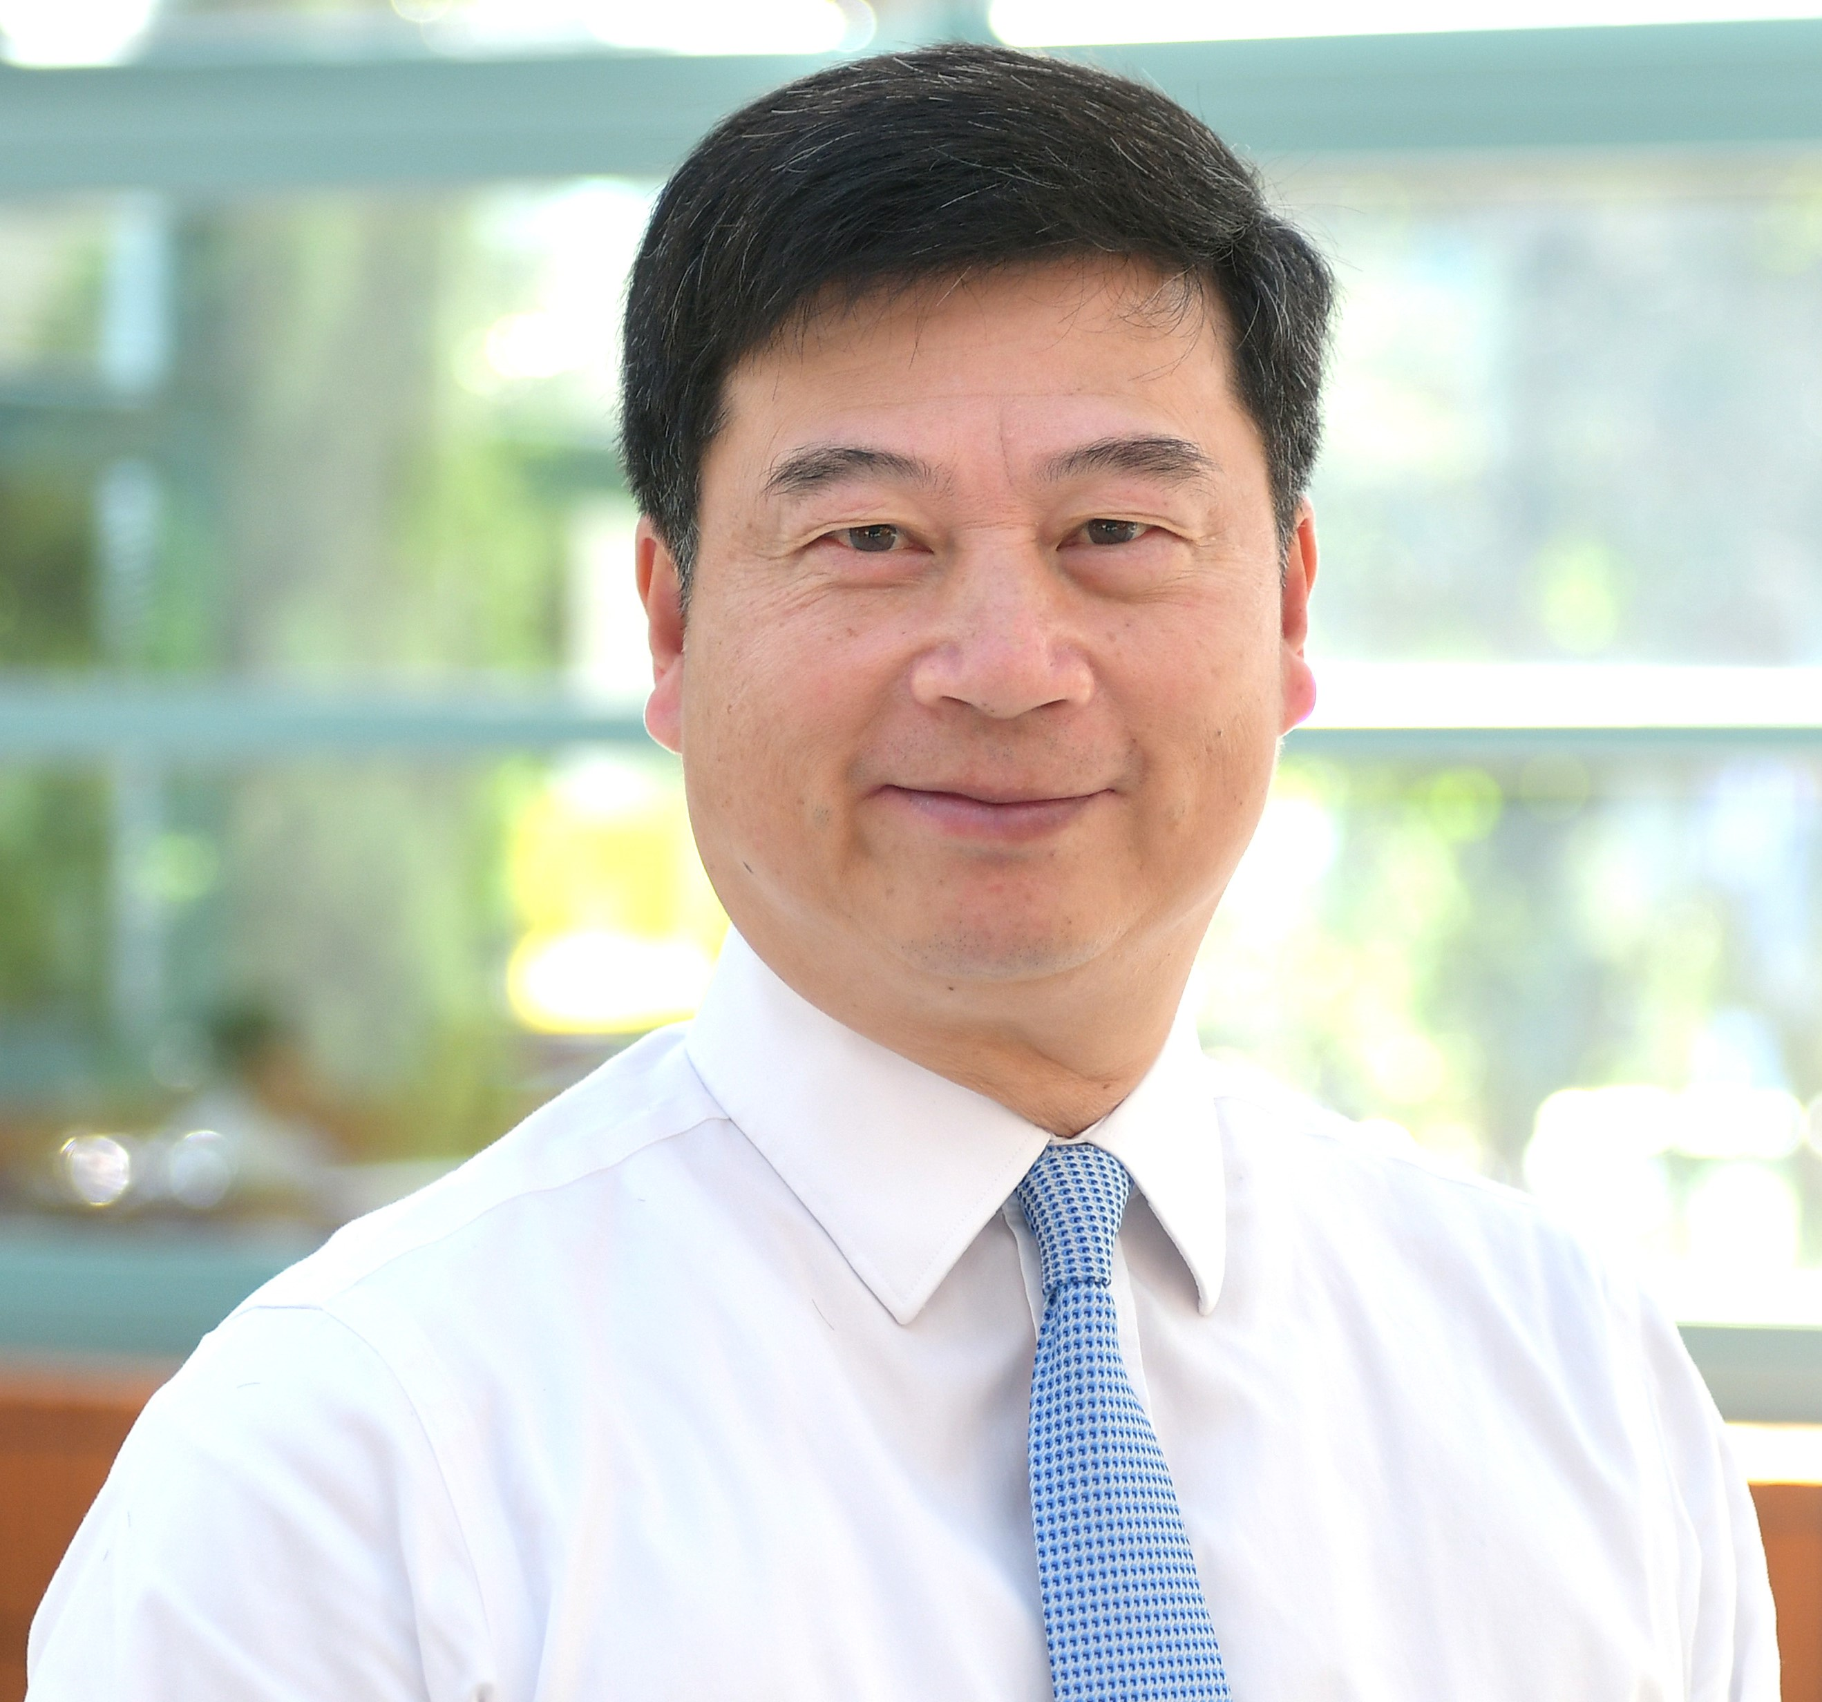 | English Name：  Pui-Yan Kwok
Chinese Name：

郭沛恩

Current Position:
Academician and Director, Institute of Biomedical Sciences, Academia Sinica
Henry Bachrach Distinguished Professor, University of California, San Francisco
Education/Training:
AB (Hons), Chemistry, University of Chicago
MS, Human Biology, University of Chicago
PhD, Organic Chemistry, University of Chicago
MD, University of Chicago Pritzker School of Medicine
Resident and Chief Resident in Dermatology, Washington University School of Medicine, St. Louis
Professional and Research Experience:
Postdoctoral Fellow, Department of Genetics, Washington University School of Medicine, St. Louis
Visiting Scientist, Department of Molecular Biotechnology, University of Washington, Seattle
Assistant and Associate Professor, Dermatology and Genetics, Washington University, St. Louis
Henry Bachrach Distinguished Professor, Dermatology and Cardiovascular Research Institute, University of California, San Francisco
Distinguished Research Fellow and Director, Institute of Biomedical Sciences, Academia Sinica
Awards and Honors:
Fellow, the World Academy of Sciences (TWAS) for the Advancement of Science in Developing Countries, 2022
Chen Award for Distinguished Academic Achievement in Human Genetic and Genomic Research, HUGO (Human Genome Organization), 2022
Fellow, American Association for the Advancement of Science, 2020
Academician, Academia Sinica, Taiwan, 2018
Distinguished Service Award, University of Chicago Pritzker School of Medicine, 2017
Elected Member of the American Dermatological Association, 2008
Visiting Distinguished Professor, Physician Scientist Training Program, UC-Davis, 2004
Siu Lien Ling Wong Visiting Fellow, Chung Chi College, Chinese University of Hong Kong, 2004
Selected Recent Publications:
- Shieh JT, Penon-Portmann M, Wong KHY, Levy-Sakin M, Verghese M, Slavotinek A, Gallagher RC, Mendelsohn BA, Tenney J, Beleford D, Perry H, Chow SK, Sharo AG, Brenner SE, Qi Z, Yu J, Klein OD, Martin D, Kwok PY, Boffelli D. Application of full-genome analysis to diagnose rare monogenic disorders. NPJ Genom Med. 2021; 6:77.
- Wei CY, Yang JH, Yeh EC, Tsai MF, Kao HJ, Lo CZ, Chang LP, Lin WJ, Hsieh FJ, Belsare S, Bhaskar A, Su MW, Lee TC, Lin YL, Liu FT, Shen CY, Li LH, Chen CH, Wall JD, Wu JY, Kwok PY. Genetic profiles of 103,106 individuals in the Taiwan Biobank provide insights into the health and history of Han Chinese. NPJ Genom Med. 2021; 6:10.
- Mostovoy Y, Yilmaz F, Chow SK, Chu C, Lin C, Geiger EA, Meeks NJL, Chatfield KC, Coughlin CR, Surti U, Kwok PY, Shaikh TH. Genomic regions associated with microdeletion/ microdupli-cation syndromes exhibit extreme diversity of structural variation. Genetics. 2021; 217:iyaa038.
- Wong KHY, Ma W, Wei CY, Yeh EC, Lin WJ, Wang EHF, Su JP, Hsieh FJ, Kao HJ, Chen HH, Chow SK, Young E, Chu C, Poon A, Yang CF, Lin DS, Hu YF, Wu JY, Lee NC, Hwu WL, Boffelli D, Martin D, Xiao M, Kwok PY. Towards a reference genome that captures global genetic diversity. Nat Commun. 2020; 11:5482.
- Levy-Sakin M, Pastor S, Mostovoy Y, Li L, Leung AKY, McCaffrey J, Young E, Lam ET, Hastie AR, Wong KHY, Chung CYL, Ma W, Sibert J, Rajagopalan R, Jin N, Chow EYC, Chu C, Poon A, Lin C, Naguib A, Wang WP, Cao H, Chan TF, Yip KY, Xiao M, Kwok PY. Genome maps across 26 human populations reveal population-specific patterns of structural variation. Nat Commun. 2019; 10:1025.
- Wong KHY, Levy-Sakin M, Kwok PY. De novo human genome assemblies reveal spectrum of alternative haplotypes in diverse populations. Nat Commun. 2018; 9:3040.
- Hoffmann TJ, Theusch E, Haldar T, Ranatunga DK, Jorgenson E, Medina MW, Kvale MN, Kwok PY, Schaefer C, Krauss RM, Iribarren C, Risch N. A large electronic-health-record-based genome-wide study of serum lipids. Nat Genet. 2018; 50:401-413.
- Hoffmann TJ, Ehret GB, Nandakumar P, Ranatunga D, Schaefer C, Kwok PY, Iribarren C, Chakravarti A, Risch N. Genome-wide association analyses using electronic health records identify new loci influencing blood pressure variation. Nat Genet. 2017; 49:54-64.
- Mostovoy Y, Levy-Sakin M, Lam J, Lam ET, Hastie AR, Marks P, Lee J, Chu C, Lin C, Dzakula Z, Cao H, Schlebusch SA, Giorda K, Schnall-Levin M, Wall JD, Kwok PY. A hybrid approach for de novo human genome sequence assembly and phasing. Nat Methods. 2016; 13:587-90.
- Mak AC, Lai YY, Lam ET, Kwok TP, Leung AK, Poon A, Mostovoy Y, Hastie AR, Stedman W, Anantharaman T, Andrews W, Zhou X, Pang AW, Dai H, Chu C, Lin C, Wu JJ, Li CM, Li JW, Yim AK, Chan S, Sibert J, Dzakula Z, Cao H, Yiu SM, Chan TF, Yip KY, Xiao M, Kwok PY. Genome-Wide Structural Variation Detection by Genome Mapping on Nanochannel Arrays. Genetics. 2016; 202:351-62.

