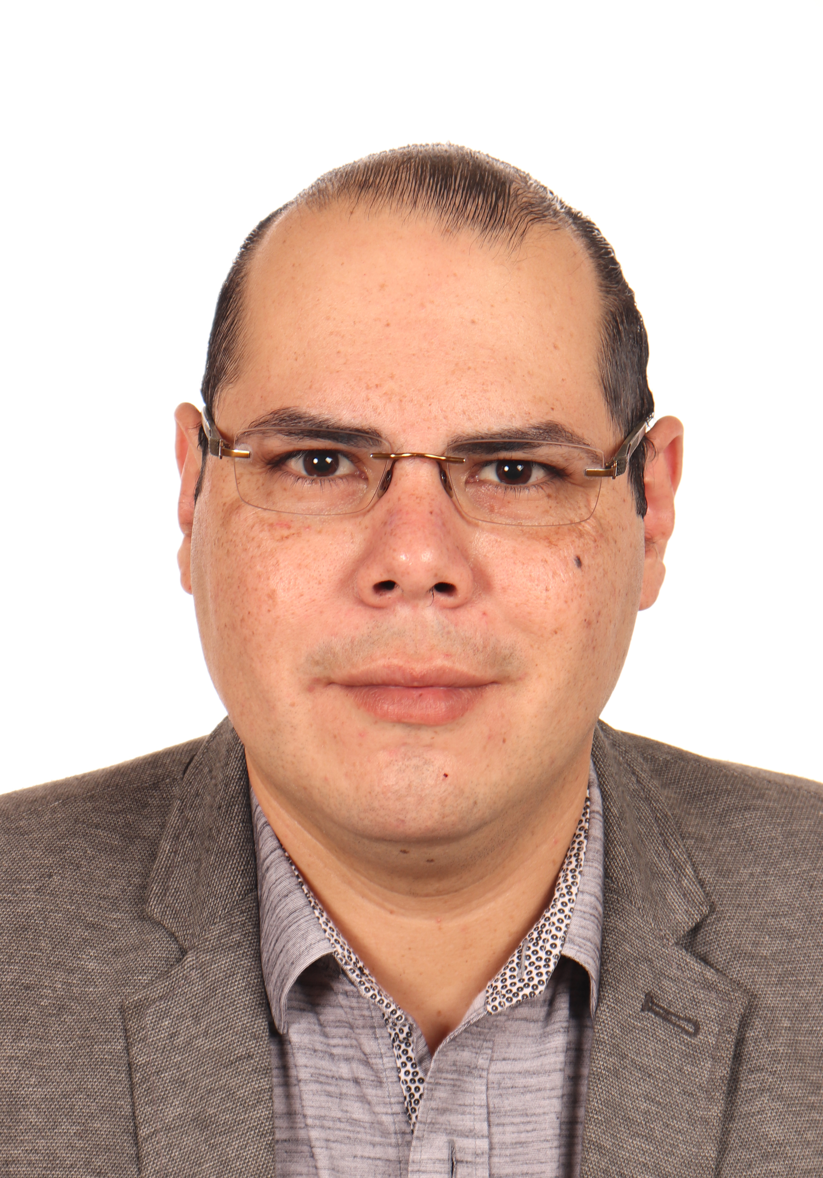
Elías Humberto Peraza Castaneda
EVOLUTIONARY ECONOMIST FOCUSED ON INNOVATION SYSTEMS
San José neighborhood, 5th South Avenue, N°4-5 A. Ahuachapán, El Salvador
- Single - Identification: 03856032-7 – Driver's License: 0101-261187-101-7 – Age: 34 years old
Residence Telephone: (503) 2413-0017 - Mobile: (503) 7748-7322
E-mails: eliasperaza_1900@hotmail.com, elias.peraza@mined.gob.sv
LinkedIn Profile: https://www.linkedin.com/in/el%C3%ADas-humberto-peraza-castaneda-61739127/
ORCID Profile: https://orcid.org/0000-0003-1900-0513
Professional Profile

2022 – Young Scientist affiliated as a member of the World Academy of Sciences-Latin America and the Caribbean Section (TWAS-LACREP)

2019 – Ph.D. in Economics- Outstanding CUM LAUDE Mention from the Universities of Burgos, Salamanca, and Valladolid (Spain).

2011 - Master in Business Management from Innovation and Internationalization from the University of the Basque Country in Bilbao, Spain with a final average of 9.26.

2009 - Best student at the University of El Salvador with an honorary CUM of 9.55 obtaining the Central American Award for Academic Excellence "Rubén Darío" (representative of El Salvador).

2004 – Maximum overall score (1900) in the MINEDUCYT PAES test.

Competencies: Adaptability to multicultural environments, communication skills and teamwork. Highly responsible, persevering, focused on goals and results.

At the UES I excelled in numerical subjects related to financial management, and in Spain in matters of marketing, sustainable development management, economics of technological change and multivariate analysis.

Work Experience

Ministry of Education, Science and Technology
Position: Manager of Educational Technological Prospective
Time worked: May 2022 – current
Telephone:(503) 2592-4302
Functions and Achievements
Carry out studies and design strategies in the field of science, technology, and innovation with a critical perspective, prioritizing topics of interest to the national education system; supervise continuous analysis, as well as cooperate in the formulation and/or monitoring of emerging technology projects, generating skills in students that allow them to insert themselves into the Fourth Industrial Revolution, thus promoting convergence with emerging and advanced nations.

Ministry of Education, Science and Technology
Position: Chief of Research in Educational Technologies
Time worked: July 2021 – May 2022
Telephone:(503) 2592-4219
Functions and Achievements
Coordinate the conduct of studies in different areas of the educational field, emphasizing the technological edge with a critical perspective, prioritizing topics of interest for the national educational system, facing the Fourth Industrial Revolution, to converge with emerging and advanced nations.

Ministry of Education, Science and Technology
Position: Chief of Business Intelligence and Communication of the Technology Parks Management
Time worked: September 2012 – June 2021
Telephone:(503) 2592-3060
Functions and Achievements
Develop Sectoral Studies (Business Intelligence), Innovation Prospects, as well as Corporate Communication Strategies that promote both selective and massive dissemination of achievements, research, products, and innovative processes that are developed in the Technology Parks of El Salvador, in such a way that an empowerment of the economic and social community of the country be achieved.

League Central America Est.09
Position: Stock Market Financial Analyst
Time worked: December 2011 - April 2012
Telephone:(503) 2340-9305/2340-9306
Functions and Achievements
As a Financial Analyst, perform low-value operations in the US stock market, analysis of financial statements of companies of different classes (vertical, horizontal and ratios). This was to finance corporate social responsibility projects in surrounding areas in coordination with the General Manager.

United Transport of the West – Project
Position: Cost Consultant
Time worked: August 2009 - November 2009
Telephone: (503) 2440-9252
Functions and Achievements
Analysis of the main operating and administrative costs of the company and preparation of a manual for their respective reduction. It is important to note that the work was carried out under a program of the Chamber of Commerce and Industry of El Salvador, and that certain parts that could be published with the authorization of the company were used to prepare a general cost reduction manual in the services sector.

Formal Studies

UNIVERSITIES OF BURGOS, SALAMANCA AND VALLADOLID, SPAIN – JUNE 2019
Ph.D. in Economics
Achievements: Outstanding Qualification with CUM LAUDE Mention. Thesis called: "The dynamics of the sectoral innovation system of the agri-food industry in El Salvador from an evolutionary perspective".

UNIVERSITY OF THE BASQUE COUNTRY, SPAIN – SEPTEMBER 2011
Official Master's Degree in Business Management from Innovation and Internationalization.
Achievements: Outstanding final average of 9.26. Thesis called: "The coordination between the marketing plan and the Local Agenda 21 for a competitive and sustainable management of tourist destinations."

UNIVERSITY OF EL SALVADOR (UES) - NOVEMBER 2009
Graduate of Business Administration
Achievements: Central American Award for Academic Excellence "Rubén Darío" for the student with the best academic performance of the University of El Salvador in 2008. Honorary Graduation and Thesis exemption for Academic Excellence C.U.M.: 9.55 in 2009

LA PROVIDENCIA SCHOOL- NOVEMBER 2004
Bachelor General
Achievements: Special PAES Award (FANTEL Scholarship) – Note: 1900 (Maximum Global Score) from the Ministry of Education, being awarded the title of first bachelor of Ahuachapán and the Western region, ranked third nationally.

Languages

Native Language: Spanish

Language 1: English level B2+ of the Common European Framework by the British Council and normal program completed by the American School.

Research and Training Stays

Christopher Freeman Center (CRIS-IS.ORG) and Globelics, 2022-2023 (in progress)
International Lecture Series Innovation Systems-102- Empirical articles using the innovation systems approach.

Christopher Freeman Center (CRIS-IS.ORG) and Globelics, 2021
International Lecture Series Innovation Systems-101- Theoretical developments on the Innovation Systems approach.

Salvadoran Foundation for Economic and Social Development (FUSADES) -PROINNOVA, 2020
Workshop "Technology Watch: Mining and Data Analysis"

Science and Technology Policy Institute (STEPI) of South Korea, 2019
High level Course: Planning and Development of Science and Technology Parks (STP) Policy, and Technology Transfer and Commercialization.

Association of Social Economics, 2016
ASE Summer School in Social Economics at Bilbao, Spain.

CTS+I OEI Chair- Institute of Science and Technology Studies of the University of Salamanca, 2016
II International Seminar on Social Studies of Science and Innovation.

Institute of Innovation and Knowledge Management (INGENIO) of the Polytechnic University of Valencia-CSIC, 2016
Short Research Stay in Innovation Systems: quantitative and qualitative methods.

University of Valladolid, 2015
Course "How to write abstracts and articles in English.”

ProQuest, 2015
Course on the RefWorks bibliographic manager

Spanish Foundation for Science and Technology (FECYT), 2014
Scopus Advanced Level Training

Wiley Corporation, 2014
Training “Writing great papers in international journals A introduction for researchers”

Economic Commission for Latin America and the Caribbean (ECLAC), 2013
Innovation Policies Course for Public Managers.

Ibero-American Secretariat, Agency for Development Cooperation of Extremadura and Inter-American Institute for Cooperation on Agriculture (IICA), 2012
"Access and use of ICTs for the Development of Central American Rural Territories"
University of the Basque Country, University of Deusto-Financial Congress, 2011
Financial Congress Digital Meeting at Bilbao, Spain.
BiscayTIC and the University of the Basque Country, 2011
Ibero-American Meeting of Digital Cities.

Congresses and Academic Events

International

V International Workshop on Economic Policy (2022): "Economic Policy Agents at critical moments", University of Valladolid, Spain (Online). With the communication "Sectoral Systems of Innovation before Sustainable Development: the case of the agri-food industry of El Salvador".

Webinar: Science and Sustainability, Solutions for the Caribbean and Central America organized by TWAS Young Affiliates Network and University of Costa Rica (online) 2021. With the communication “How to strengthen innovation systems in a developing country”
“United by Science”- Nobel Prize Dialogue Latin America and the Caribbean 2021 (Online). Participation in a dialogue table with the Nobel Prize in Medicine in 2011, PhD. Elizabeth Blackburn, selected by the Brazilian Academy of Sciences.

17th Globelics International Conference: Innovation systems and sustainable development. New strategies for growth, social welfare and environmental sustainability in San José, Costa Rica (Virtual). As a listener.

I Educational Research Forum of the SICA region 2021 in San José, Costa Rica (Virtual). With the communication Promotion of Educational Research of MINEDUCYT-El Salvador in Times of COVID19.

“Science in Latin America: Today and Tomorrow” which includes 22nd TWAS LACREP Young Scientist Conference and 1stTYAN Regional Conference for Latin America and Caribbean Region. With the poster Innovation Behavior of Salvadorian Food & Beverage Industry Firms.

XIV International Conference on Economic Policy 2019 in Barcelona, Spain.
With the communication "Innovation in low technology sectors: the case of Salvadoran agri-food companies".

STI Conference 2016 – Valencia: Peripheries, frontiers and beyond. With the paper “Innovation dynamics of Salvadoran agri-food industry from an evolutionary perspective”.

13th International Conference Developments in Economic Theory and Policy (2016) organized by the University of the Basque Country-UPV/EHU and the University of Cambridge. With the paper Is homogeneous the innovative behavior of low technology`s Spanish firms?

EU-SPRI Forum Early Career Researcher (ECC) 2016: “Science, Innovation and the University: Keys to Social Impact”, at INGENIO/UPV, Valencia, Spain. With the paper "The innovative Behavior of Agri-Food Industry`s Firms in El Salvador".

V Meeting of Doctoral Students of the Institute of Science and Technology Studies of the University of Salamanca, 2015
Presentation of the Research Plan on the Dynamics of the Sectoral System of Innovation of the Salvadoran Agri-food Industry.

XII International Conference on Economic Policy 2015 in Toledo, Spain
With the communication "Innovation in the European industrial sector in the face of the change in the economic cycle".

XXIX Annual Conference of the "European Academy of Management and Business Economics" (AEDEM) in San Sebastián, Spain. 2015
With the communication "Sectoral Systems of Innovation in Spain: A typology based on the survey on innovation in companies".

National

Event of the Network of Researchers of the Central Reserve Bank (REDIBACEN) 2019. With the presentation "The Dynamics of the Sectoral System of Innovation of the Agrifood Industry in El Salvador from an Evolutionary Perspective"

XV Scientific Conference of the Faculty of Agriculture and Agricultural Research "Julia Hill de O 'Sullivan" of the University "Dr. José Matías Delgado” (2017). With the presentation "Innovation Sector Systems: a proposal for industrial dynamism in El Salvador".

International Congress of Scientific Research and Innovation 2017, organized by the Evangelical University of El Salvador. With the presentation "The Experience of the Technological Park in Agroindustry"

Fourth Annual Conference on Food Safety and Quality 2017 of the Catholic University of El Salvador With the presentation "The evolution of the agri-food industry in El Salvador: looking to the future from history".

Event of the Network of Researchers of the Central Reserve Bank (REDIBACEN) 2017. With the presentation "Sectoral Systems of Innovation: a proposal for industrial dynamism in El Salvador"

Publications

Peraza, E. & Aleixandre, G. (2022). “Sistemas sectoriales de innovación ante el desarrollo sostenible: el caso de la política económica en la industria agroalimentaria de El Salvador”. Revista Internacional de Política Económica, 4 (2), 98-111. DOI: https://doi.org/10.7203/IREP.4.2.25805
Peraza, E. & Aleixandre, G. (2021). Innovation Behavior of Salvadoran Food & Beverage Industry Firms. Revista Finanzas y Política Económica, 13(2), 171-204. DOI: https://doi.org/10.14718/revfinanzpolitecon.2983
Peraza, E., Gómez García, J. y Aleixandre, G. (2016). “El Comportamiento Innovador de las Cooperativas en Castilla y León: Un Análisis de sus Principales Factores Determinantes”. REVESCO, 122, págs. 252-284. DOI: http://dx.doi.org/10.5209/rev_REVE.2016.v122.52025
Peraza, E. y Aleixandre, G. (2016) "Sistemas sectoriales de innovación en España: Una tipología a partir de la encuesta sobre innovación en las empresas”. Economía Industrial, 402, pp. 117-127. Link: https://www.mincotur.gob.es/Publicaciones/Publicacionesperiodicas/EconomiaIndustrial/RevistaEconomiaIndustrial/402/PERAZA%20y%20MENDIZ%C3%81BAL.pdf
Peraza, E. y Aleixandre, G. (2016). “Innovation dynamics of Salvadoran agri-food industry from an evolutionary perspective”. Chapter in Book of Proceedings STI Valencia 2016, pp.246-252. DOI: http://dx.doi.org/10.4995/STI2016.2016.4543

Personal References
MSc. Carolina Nohemy Mejía Romero
Director of Social Programs of the Ministry of Education, Science and Technology of El Salvador
Tel. +503 7285-9144 (El Salvador)

Ph.D. Guillermo Aleixandre Mendizábal
Contracted Professor Doctor of the University of Valladolid
Tel. +34 983 42 33 76 (Spain)

Ph.D. Unai Arzubiaga Orueta
Contracted Professor Doctor of the University of the Basque Country
Tel. +34 620 91 58 94 (Spain)

