CIRRICULUM VITAE

Name: NGUYEN THI THANH MAI, PhD, Professor  Position title: Vice-Chancellor, Vietnam National University Hochiminh City (VNU-HCM); Head of Oustanding Research Group belong to Medicinal Chemistry Program, VNU-HCM. | 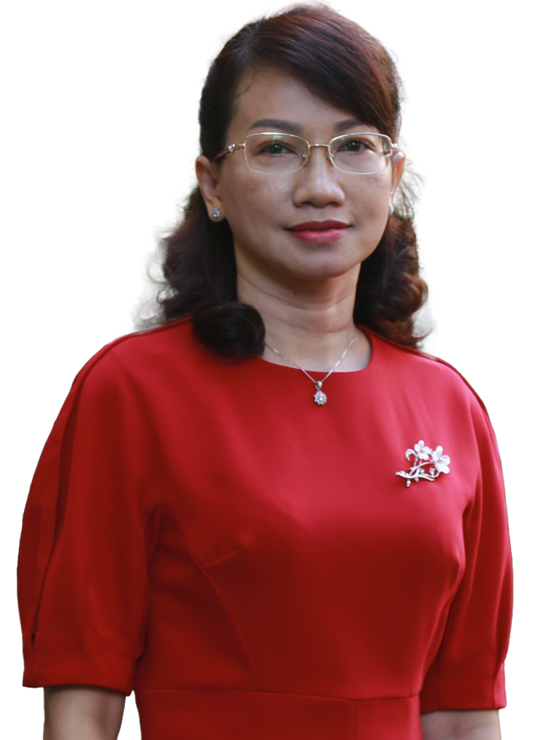
Education/training:
Institution and location | Degree | Completion date | Field of study
University of Science, VNU-HCM, Vietnam | Bachelor | 1996 | Chemistry
University of Science, VNU-HCM, Vietnam | Master | 2000 | Analytical Chemistry
University of Toyama, Japan | PhD | 2005 | Pharmaceutical
I. Personal Statement
Skilled and highly-experienced researcher with an extensive background in the natural product isolation and medicinal chemistry. Has a PhD degree in medicinal chemistry and over a decade of experience in the field. Wide range of experience covering team management and conceptualizing development projects.
II. Current and Past Positions
- 2024-present: Vice-Chancellor, Vietnam National University Hochiminh City
- 2021-2024: Vice-President, University of Science, VNU-HCM
- 2022-2025: Principal, High School for the Gifted, VNU-HCM
- 2014-2024: Head of Department of Medicinal Chemistry, University of Science, VNU-HCM
- 2013-2021: Dean of Faculty of Chemistry, University of Science, VNU-HCM
- 2009-2013: Head of Department of Analytical Chemistry, University of Science, VNU-HCM
- 2007-2012: Vice-Dean of Faculty of Chemistry, University of Science, VNU-HCM
- 01/2010-04/2010: Visiting Scientist at Institute of Natural Medicine, University of Toyama, Japan
- 09/2007: Visiting Scientist at Roskild University, Denmark
- 2001-2013: Lecturer, Faculty of Chemistry, University of Science, VNU-HCM
III. Awards and Honors
Award and Fellowship:
2022: Kovalevskaia Prize 2021 - Outstanding Achievements in Science by an Individual Demale Scientits
2019: Ho Chi Minh City Creative Award, People’s Committee of Ho Chi Minh City
2017: Outstanding Science Publication Award for Medicinal Chemistry Research Group, VNU-HCM
2010: Visiting Scholar at University of Toyama, Japan
IV. Scientific achievements
* Key research:
- Study on xanthine oxidase inhibitory activity of Vietnamese medicinal plants and structure of active compounds for future implementation to drugs for treatment of gout.
- Study on α-glucosidase inhibitory activity of Vietnamese medicinal plants and structure of active compounds for future implementation to drugs for treatment of diabetes.
- Study on tyrosinase inhibitory activity of Vietnamese medicinal plants and structure of active compounds for future implementation to products used as cosmetic skin-whitening agents.
- Study on xanthine oxidase inhibitory activity of Vietnamese medicinal plants and structure of active compounds for future implementation to drugs for treatment of Alzheimer’s disease.
- Study on natural anti-inflammatory agents for pain relief to develop products for treatment of arthristis
- Study on urease, Helicobacter pylori inhibitory activity of Vietnamese medicinal plants to develop products for treatment of peptic ulcer.
* Principle investigator of 14 projects:
- 10 projects at ministerial-level.
- 04 projects at provincial-level.
* Scientific articles: 160 articles
- 90 international papers.
- 70 national papers.
* Academic books:
- 01 monograph.
- 01 international academic chapter book.
- 01 textbook.
* 07 accepted patents from Department of Intellectual Property.
* Developed 2 dietary supplement products:
- SOLAJOINT: a natural supplement for anti-athristic prepared from nanopartical of Solanum procumbens.
- PINOCARE: a natural supplement for peptic ulcer prepared from the standardized extract of Boesenbergia pandurata.
* Outstanding research group belong to Medicinal Chemistry Program, VNU-HCM.
* Reviewer for national and international academic journals. H_{index}: 22 (follow by Publish or Perish), citation: 1364.
V. Achievements in education
- Has opened 03 new specialized subjects and 06 others at university level, 01 subjects at master level and 01 at PhD level.
- Has supervised 3 PhD students (women) and 35 Master students (½ women).
VI. Contribution to the development of the university, and ministerial units
* Has opened 9 new undergraduate and postgraduate training programs:
- “The Master’s degree program in Chemistry” project in 2021;
- “The integrated bachelor’s – master’s programs (BS-MS) in Chemical Engineering Technology” project in 2021;
- “The integrated bachelor’s – master’s programs (BS-MS) in Chemistry” project in 2021;
- “The high-quality undergraduate training program in Chemistry” project in 2019;
- “The postgraduate training program specialized in Teaching Experimental Chemistry" project in 2018;
- “The talented bachelor’s degree program in Chemistry" project in 2013 & 2018;
- “The undergraduate training program in Chemical Engineering Technology” project in 2016;
- “The high-quality undergraduate training program in Chemistry” project in 2016;
- “The undergraduate training program specialized in Medicinal Chemistry" project in 2014.
* Has successfully implemented projects to innovate teaching methods according to the CDIO model and the 4.0 educational model of the Faculty of Chemistry.
* Has successfully completed the evaluation of the training program in Chemistry according to AUN-QA standards in 2016.
* Through the projects that I lead, the annual revenue from these programs increases by about 20-25 billion VND/year, contributing to the increase of the school's revenue and the 3-5 times increasing in the income of lecturers of the Faculty compared to that of the year 2013; and also contributing to many modern equipment for training and scientific research.
* Lead the Faculty of Chemistry to become a strong scientific research unit with annually publishing 40-60 prestigious international articles and implementing 40-50 scientific research topics at all levels.
* Lead the Faculty of Chemistry to obtain many gorgeous achievements such as: Certificate of Merit from the Prime Minister (in 2021); Certificate of Merit from the Ministry of Education and Training (2017, 2020); Emulation flag of the Ministry of Education and Training (2020).
* Has coordinated with the Party Committee and the Administrative Board of the University of Science in developing the strategic plan for the period 2015-2020 and 2020-2025.
VI. Contribution to the women’s movement at the unit
- Reviewed, encouraged, implemented the planning of female cadres in management positions at the Faculty and the University.
- Rearranged the research directions, in which there are 09 female staff who are the heads of research groups.
The proportion of female lecturers in the Faculty of Chemistry is 44%. The Faculty's female scientists have actively contributed in training and scientific research activities with the number of scientific publications accounting for about 50% of the publications of the whole Faculty.
- 90% of female staff of the Faculty have won the title of "Good at school, Good at home" at university level and 50% at VNU level every year.
5. Contribution to charity and humanitarian activities
- Mobilized contributions to many scholarships for students from alumni and companies worth 200-300 million VND/year.
- Mobilized material and spiritual supports for students facing difficulties during the recent Covid-19 epidemic from alumni with an amount of nearly 500 million VND.
- Mobilized and organized the production of 10,000L of hand sanitizer, equivalent to 100,000 products in 100ml bottles, to provide to the community during the Covid-19 epidemic season.
- Actively supported the victims in the flooded regions and conducted many charity trips.

