Curriculum vitae: Prof. S. Samar Hasnain
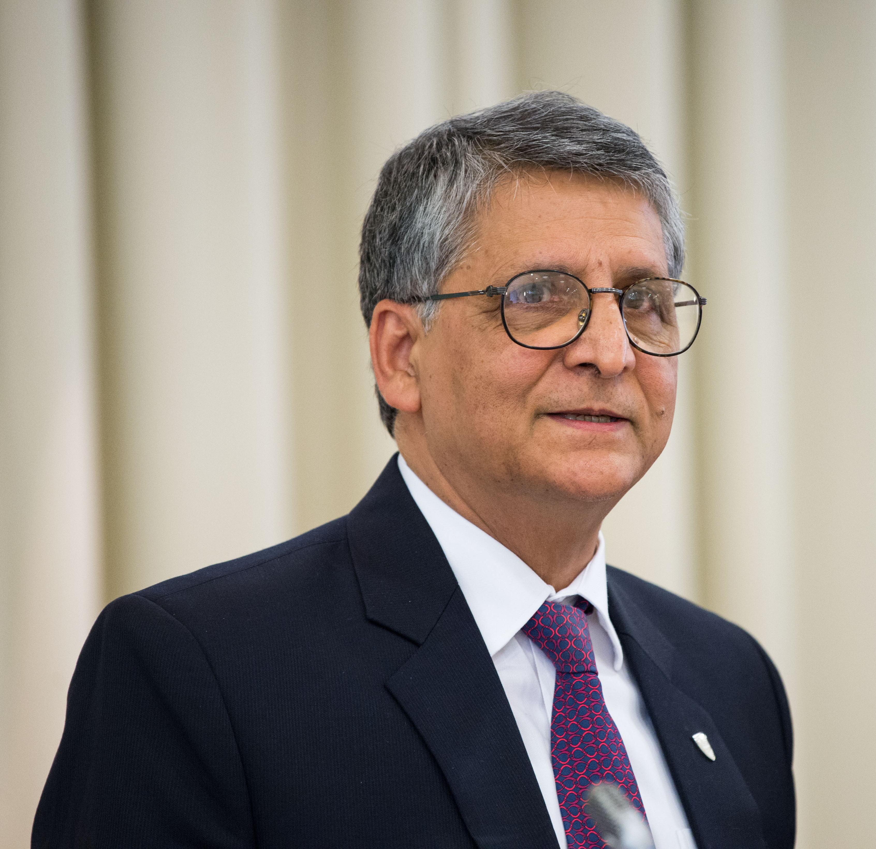
Max Perutz Professor of Molecular Biophysics, Department of Biochemistry, Cell and Systems Biology, Life Sciences Building, Faculty of Health & Life Sciences, University of Liverpool, UK
Phone: 0151 795 5149, Email: S.S.Hasnain@liverpool.ac.uk
* Education
B. Sc. Honours (1970) (upper second) University of Karachi, Pakistan
M. Sc. (1972) (FIRST, Merit position) University of Karachi, Pakistan
Ph. D. (Synchrotron Radiation Photophysics & molecular crystals) awarded in 1977
University of Manchester, UK
* Membership/Honours
1974-76 | J R Ashworth Research Scholarship - University of Manchester Postgraduate Awards
1991 | Fellow of the Institute of Physics (IoP), UK
1997 | Fellow of The World Academy of Sciences (TWAS), Italy
2002 | Fellow of the Royal Society of Chemistry (RSC), UK
2012 | Japan Society for Promotion of Science (JSPS) Invitation Fellowship
2017 | Foreign Fellow, Pakistan Academy of Sciences (PAS), Pakistan

* Professional Positions
1976-1977 | SRC Research Fellow, Physics Department, Manchester University
1977-1978 | DESY Research Fellow at HASYLAB, DESY, Hamburg, Germany
1978-1979 | SRC Research Fellow, Chemistry and Medical Biophysics Departments, University  of Manchester, UK
1979-1981 | Higher Scientific Officer, Synchrotron Radiation Source, Daresbury Laboratory, UK
1981-1989 | Senior Scientific Officer, Synchrotron Radiation Source, Daresbury Laboratory, UK
1989-2000 | Band 3, Head of Molecular Biophysics Group, Daresbury Laboratory, UK
1991-2001 | Visiting Professor of Molecular Biophysics, De Montfort University, Leicester
2000-2005 | Individual Merit Band 2, CCLRC Daresbury Laboratory
2001-2008 | Visiting Professor of Molecular Biosciences, Liverpool John Moores University, UK
2001-2006 | Coordinator Northwest Structural Genomics Centre/Consortium
2005-2008 | Individual Merit Band 1 & STFC Senior Fellow, STFC Daresbury Laboratory
2011-2015 | International Lead for the Faculty of Health & Life Sciences, University of Liverpool
2008- | Max Perutz Professor of Molecular Biophysics, Institute of Integrative Biology, University of Liverpool, UK
2011- | Co-Director, Barkla X-ray Laboratory of Biophysics, University of Liverpool

* Editorial Boards and Advisory Committees
1993-2002 | Founding Editor of the IUCr’s Journal of Synchrotron Radiation
1994-2003 | Co-Editor of the IUCr’s Journal of Applied Crystallography.
2002- 2012 | Co-Editor and Current Events editor, Journal of Synchrotron Radiation
2008-2012 | Editor (for Biophysical Methods), Current Opinion in Structural Biology
2012- | Editor, Current Opinion in Structural Biology
2012- 2018 | Editor-in-chief of the International Union of Crystallography Journals including  ACTA CRYSTALLOGRAPHICA A to F, Journal of Applied Crystallography and  the Journal of Synchrotron Radiation
2013-2018 | Founding editor in chief of IUCrJ, a flagship journal of the IUCr
2018- | Member, International Editorial Advisory Board, IUCrJ.
2002- 2006 | Chairman, SESAME Programme Advisory Committee
2004 - | UK's representative on the council of UNESCO's sponsored SESAME centre, Appointed by the Chief Scientific Advisor to HM’s Government
2006- 2015 | Member, Science Advisory Committee of SESAME
2016- | Chairman, SESAME Programme Review Committee
2019- | Expert representative on UNESCO’s UK National Commission
2007- 2015 | Member of Life Sciences Review Panel, SOLEIL synchrotron, France
2010-2012 | Chair, SAC, National Resource for Soft X-ray Crystallography, Advanced Photon  Source, Argonne, USA

* Other professional experience
1981 Joint Chairman with Prof David Garner, FRS, First International Conference on EXAFS ‘EXAFS For Inorganic Systems’, 28-29 March 1981, Daresbury.
1988 Chairman, Second International conference on Biophysics and Synchrotron Radiation, Chester, U.K.
1990 Chairman, 6th International XAFS Conference, York, U.K.
2007 Joint Chair with Late Dame Louise Johnson, FRS, 9th International Conference on Biology and Synchrotron Radiation, Manchester, UK.
2010-18 Academic Lead of the University of Liverpool’s Science & Society Lectures series– the series has attracted many notable speakers including Nobel prize winners as well as those responsible for major organizations, e.g. Director-General of CERN, President of IUCr, Director of Wellcome Trust, CE of BBSRC & STFC where they have been able to present the benefits to society for funding of science in a variety science disciplines.
2013-14 Member of the UNESCO-IUCr’s organizing and programme committees for the International Year of Crystallography.
2014-18 SPECIAL VISITING RESEARCHER – Pesquisador, Especial (PVE) – CNPq – University of Sao Paulo, Sao Carlos, Brazil.
2015-24 Member of the Royal Society’s Research Grant Biological Panel
2016 Joint Chair with Dr Svetlana Antonyuk, BBS2016 “New horizons and emerging biomedical challenges for biophysics”
2018 Joint Chair with Prof Richard Catlow, FRS, ‘50 Years of Synchrotron Radiation and its Global impact (UKSR50)’, 26-29 June 2018, Liverpool
2024- Jury member for L’Oréal-UNESCO For Women in Science UK and Ireland Young Talent Awards

*Present position and brief history
I was awarded the J R Ashworth Research Scholarship in 1974 from the University of Manchester and completed my PhD in experimental Physics in 1976, working on the first- generation synchrotron source NINA with the SR pioneers of the UK (Ian Munro & Scot Hamilton; see special issue “Pioneers of Synchrotron Radiation”, SRN, Volume 28 issue 4, 2015). After spending a year as a PDRA with Manchester Physics, I joined Prof Ernst Koch at DESY in Hamburg as a DESY Fellow where I was able to participate in a variety of experiments ranging from spectroscopy to diffraction of Molecular Crystals. During my stay at DESY, the Synchrotron Radiation team led by Koch and Kunz created the HASYLAB (Hamburg Synchrotron Laboratory). On my return to the UK in October 1978, I took a conscious decision to use my Physics and synchrotron background at the interface of Chemistry and biomedical science thus joining an interdisciplinary team at Manchester derived from Chemistry (Dave Garner) and Medical Biophysics (David Hukins) departments who had just started the UK’s first biological XAFS project working on metallo-enzymes and calcification. A year later, in 1979, I joined the national effort of establishing the world’s first dedicated synchrotron radiation source (SRS) as a full-time scientific staff member of the Daresbury national laboratory. Here I began to develop an independent programme on structure-function studies of metalloproteins while developing instrumentation, techniques and analysis approaches. Early on, I was fortunate enough to interact with Max Perutz closely and publish a few papers on hemoglobin and myoglobin. In 1986-87 I went to two protein crystallographic laboratories in the USA (Birmingham, Alabama (Charlie Bugg) & Seattle, Washington (Lyle Jenson & Ellie Adman)) on a sabbatical leave. I established the Molecular Biophysics group in 1989 when I was promoted to a Principal Scientist position at the SRC Daresbury Laboratory and was encouraged to focus on research combining Crystallography and XAFS. I remained head of this group till March 2008 when I moved to the University of Liverpool as Max Perutz Professor of Molecular Biophysics. At Liverpool, I have established a unique combination of X-ray scattering and Protein Crystallography on an intense laboratory-based X-ray source creating the Barkla X-ray Laboratory of Biophysics, named after the Liverpool’s Nobel prize winner Charles Glover Barkla (1917).
In late 80’s, I felt the SR community needed a Journal of their own where advances in the field could be reported helping to encourage cross-fertilization among different disciplines and techniques served by synchrotron radiation. Even though SR served other than crystallographers, I was able to persuade IUCr to establish the Journal of Synchrotron Radiation in 1993 (for its journey see account from the President of IUCr at the time: Authier Acta Cryst. (2009). A65, 167–182). In October 2012, I became the Editor-in-Chief of all the IUCr Journals and proposed to create a comprehensive open access journal, IUCrJ. The journal was established in 2013 with its first issue appearing in January 2014 with me as the Founding Editor-in-Chief. In 2015, Hasnain persuaded the Executive committee of IUCr to start a dedicated section on cryoEM from 2016 in its flagship journal, IUCrJ (IUCrJ (2016) 3, 3-7). Its tenth anniversary was marked by a special issue entitled “CryoEM in the Fast Lane of Structural Biology” in July 2026.
In July 2016, he helped organize a successful BBS conference entitled “New horizons and emerging biomedical challenges for Biophysics” in Liverpool. In 2016, he extended his research programme to include cryoEM with the help of Dr. Richard Henderson. In June 2018, Prof Richard Catlow and he organized the International Conference UKSR50 in Liverpool that marked the “50 years of Synchrotron Radiation in the UK and its global impact” attracting plenary speakers from the UK, USA, Japan, Sweden, Brazil and the Netherlands. In June 2024 he organised a 2-day UK-Japan symposium covering synchrotron, XFEL and cryoEM attracting leading structural biology figures from Japan and the UK.

Research career (RESEARCH KEYWORDS): Biophysics (Synchrotron radiation & Biomolecular Sciences); Metalloproteins; Electron Transfer; Nitorgen Cycle; Oxidative Damage; Neurodegenerative diseases; infectious diseases; Enzyme mechanism; Drug discovery; Crystallography; Small Angle Scattering; XAFS; Synchrotron radiation and XFEL; cryo-EM.

