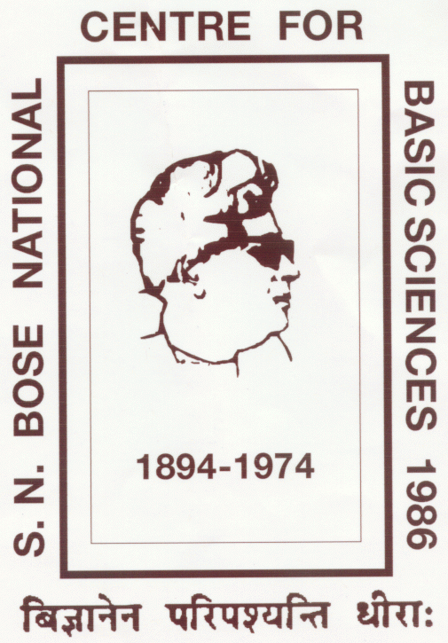 | Satyendra Nath Bose National Centre  for Basic Sciences  Block JD, Sector – III, Salt Lake, Kolkata – 700106, WB, India | website: www.bose.res.in  Email: deanap@bose.res.in / studentsprogramme@bose.res.in

Application for SNBose-TWAS Post Graduation Fellowship

Name (in CAPITAL)
Email
Mobile Number |  | WhatsApp Number
Permanent Address
Nationality |  | Passport Number
Highest Qualification
Current Affiliation
Proposed Supervisor
(at SNBNCBS)
Research Proposal
(please attach extra sheet if needed)

_______________________
Signature with date

