Call for Expression of Interest to host the
TWAS General Conference in 2024 or 2026

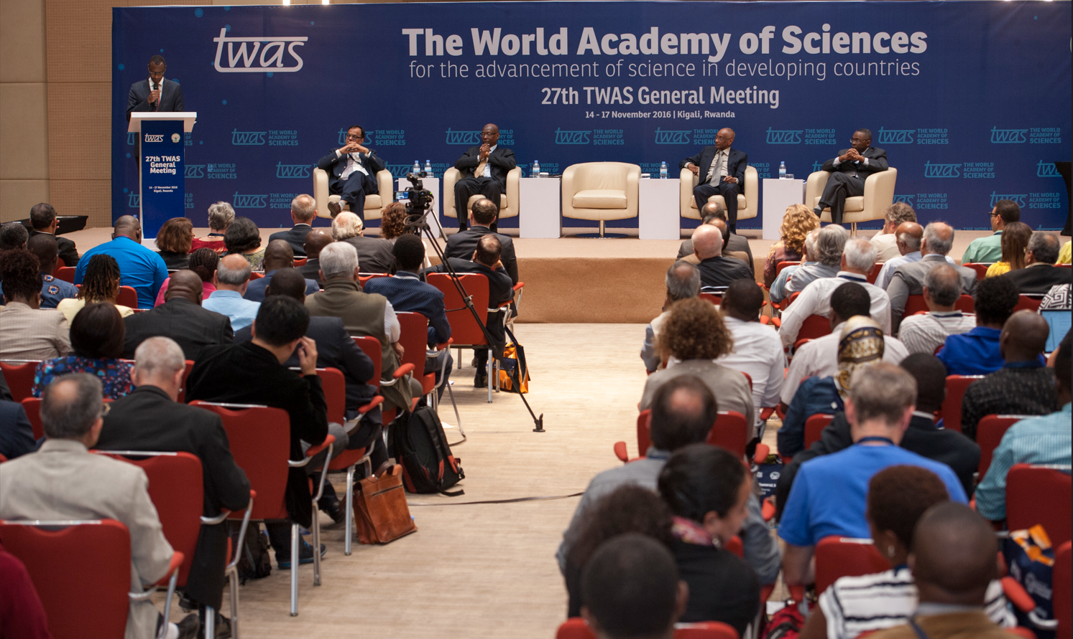
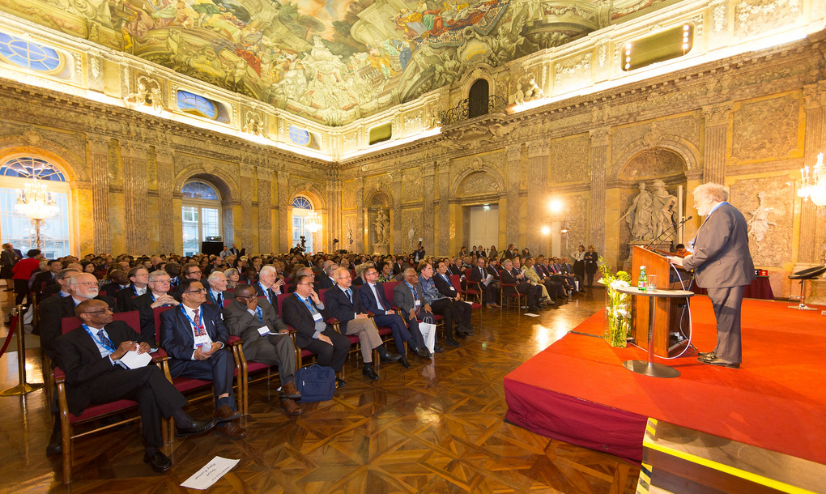

TWAS General Conferences
Introduction
TWAS General Conferences are showcases for scientific excellence in the developing world, and share an overarching theme: the importance of scientific research to human prosperity. The conferences convene elite and promising early-career scientists from the global South, government science ministers, Nobel laureates, and presidents of universities and science academies. High-ranking government officials—such as, in past years, the Heads of State of China, India, Rwanda, Senegal, Austria and Iran—often address the gatherings.
They take place every two years and are composed of:
- a closed General Meeting of TWAS Fellows and Young Affiliates to discuss Academy matters; and
- a major conference unfolding with an opening ceremony, presentation of awards, keynote lectures by Nobel Laureates and/or high-level experts, scientific symposia, ministerial sessions and award lectures
- > TWAS was founded in 1983 and officially inaugurated in 1985. The 17th General Conference, which is scheduled to take place in autumn 2024 and will last 4–5 days, will be one of the key events of the TWAS 40th Anniversary celebrations.
Hosting the TWAS General Conference will give scientists in the host country an opportunity to show the scientific work they are undertaking to an international audience of accomplished peers.

Participation
TWAS General Conferences convene a range of participants including
- Elected members of the Academy: TWAS currently has more than 1,300 elected Fellows, including some of the world's most accomplished scientists and engineers
- TWAS Young Affiliates: talented scientists under the age of 40 selected on the basis of their scientific achievements and their potential for future impact, and once their term as Affiliates has ended they are considered Alumni (the network currently has more than 400 Affiliates and Alumni)
- High-level speakers and representative of governments
- TWAS donor representatives
- Guests invited by the host
- Journalists and international press representatives
- > Participation in numbers
In-presence events: In the pre-COVID-19 era, around 300 delegates attended the last General Meeting TWAS was able to organize in presence (Trieste, November 2018).
Online events: in 2021 the online conference was actually attended by more than 600 participants who logged in from more than 80 countries. In 2022 the online conference had more than 500 participants from 75 countries with a session dedicated to the host which was livestreamed and attracted more than 2,000 viewers.
A full list of the past events is available here https://twas.org/twas-general-meetings.

Programme
Each conference surveys research successes and powerful ideas that shape science in the South and will feed into the overarching theme. The Conference usually consists of a 4–5 day event, with the first day devoted to internal Academy business meetings followed by four days of scientific sessions.
- It is a showcase for scientific excellence in the developing world with particular emphasis on the hosting country and host institutions under a general overarching theme.
- A leading public official, often the president or prime minister of the host country, opens the event and delivers the opening address. Chinese President Hu Jintao delivered an address at the 2012 meeting and Heads of State from India, Rwanda, Austria and other nations spoke in previous years at the opening ceremonies.
- Ministerial sessions, addressing critical STI issues, are usually held after the opening. These events gather ministers of science and education and government representatives from selected countries of the South and the North, including the host country which usually co-chairs the session with the TWAS President.
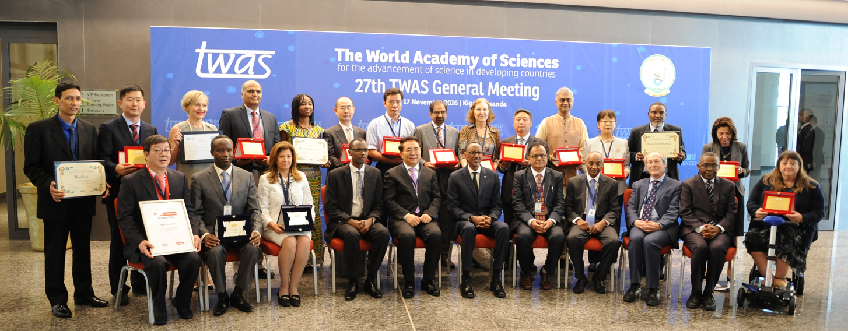
- Scientific sessions, are held throughout the conference. In each conference, one session focuses on the state of science in the host country. Young scientists are given an opportunity to discuss their research, and a series of awards and medals acknowledge the excellent work being done by scientists in developing countries.
Benefits for the hosting institutions
- Visibility: The Conference is an opportunity to showcase the state of science in the country and expose national scientists and researchers to an international forum of high-level scientists. The host may wish to organize tours to local labs or scientific institutions.
- Networking: The local scientific community has the opportunity to interact with TWAS Fellows, speakers and participants. Important networking opportunities arise which provide a platform for new collaborations and partnerships.
- Fostering the next generation of scientists: The Young Affiliates session is an excellent opportunity for young scientists to showcase their research and interact and network in addition to exposing themselves to eminent worldwide scientists.

Support requested from the host
Traditionally the hosting country covers the expenses related to:
- Accommodation and meals in a hotel (preferably 5-star) for approximately 250 participants from outside the country from one day before the meeting to one day after the meeting (approximately 1 week)
- Travel for Speakers, selected participants from S&T lagging countries, TWAS Council and Committee members (desirable)
- The accommodation and meals of the extra days for participants with flight connection problems and committee members who need to arrive one day earlier
- Full conference facilities (meeting rooms, microphones, photographer, IT support etc.)
- Local transportation (airport transfers, daily transportation from hotel to conference venue, etc.)
- Local secretarial/organizational support
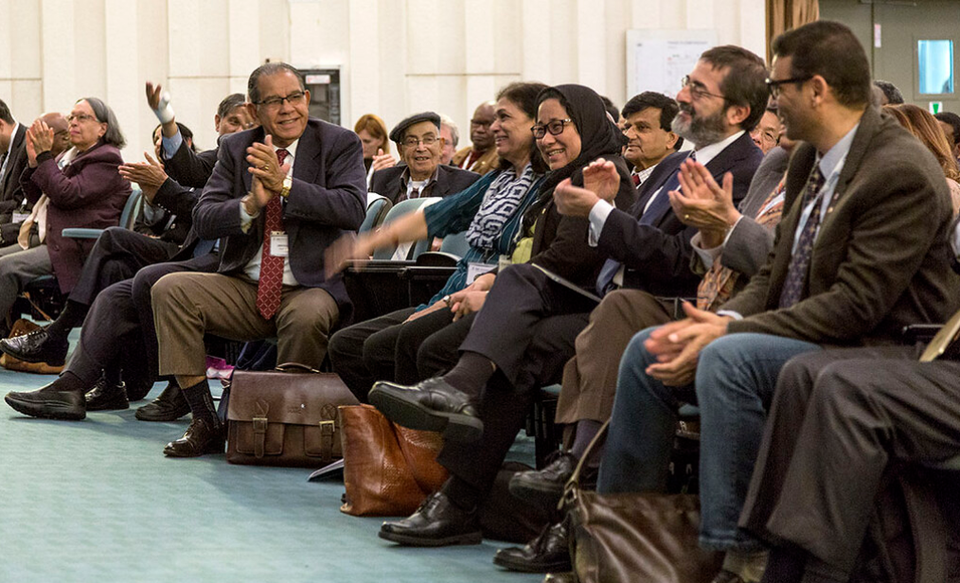
TWAS will
- Provide the programme structure and contents
- Select speakers in collaboration with host
- Issue official invitations
- Manage the registration of participants and logistical details in close liaison with local organizer/focal point
- Collect Speakers bios and abstracts
- Organize all committee meetings
- Provide strategic communication support
- Actively promote the event on social media and reach out to media contacts
- Provide secretarial and support Staff at Conference venue
Host Country Agreement
A Host Country Agreement (HCA), to be signed between UNESCO Director-General and the government of the country where the meeting will take place, will be drawn up. The HCA establishes all pertinent aspects of the meeting, including its nature and scope. It outlines responsibilities and obligations both of the Host Country and the Organization. It guarantees that all participants to the meeting enjoy the privileges and immunities provided in the 1947 Convention on Privileges and Immunities of the Specialized Agencies. Finally, in certain cases, it ensures that persons entitled and invited to attend the meeting are granted their freedom to enter into, stay and depart from its territory when on official business.

Model of Expression of Interest
To be submitted to generalmeeting@twas.org by 31 August 2023

Institution’s Headed paper –

Institution name and address: ……………
Focal point (name and email address)………………
Availability to host the TWAS General Conference in year: …………. (please indicate 2024 or 2026 or both)
Possible location and venue: ………………
Approximate dates/period of the year: ………………
Short statement describing the host’s interest in partnering: ………………
Support offered: | CONFIRMATION | COMMENTS
Accommodation and meals in a hotel (preferably 5-star) for approximately 250/300 participants from outside the country from one day before the meeting to one day after the meeting (approximately 1 week)
Travel for Speakers, selected participants from S&T lagging countries, TWAS Council and Committee members (DESIRABLE REQUIREMENT)
The accommodation and meals of the extra days for participants with flight connection problems and committee members who need to arrive one day earlier
Full conference facilities (conference and meeting rooms, microphones, photographer, IT support etc.)
Local transportation (from airport to hotel and back, daily transportation from hotel to conference venue, etc.)
Local logistical support: secretarial/organizational conference support staff
Assistance for participants visa
A focal point to liaise with TWAS Secretariat
Signature of Head of Institution ………………

