#### **Curriculum Vitae**

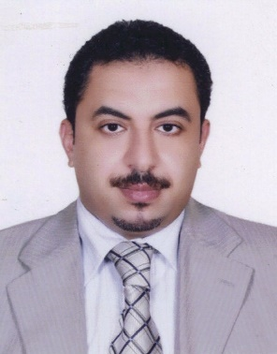

Notarization. I have read the following and certify that this *curriculum vitae* is a current and accurate statement of my professional record.

Signature 

Date 8 March 2018

**Personal Particulars**

**Name: Mohamed Fawzy Ramadan Hassanien**  
**Birth Date:** August 07, 1974 (Zagazig, Egypt).  
**Nationality:** Egyptian. **Current Position:**

-Since August 2014 Professor of Biochemistry (Food Chemistry),Biochemistry Department, Faculty of Agriculture, Zagazig University, Zagazig 44519, Egypt**.**

**Address in Egypt**

Faculty of Agriculture, Biochemistry Department, Zagazig University, Zagazig 44519, Egypt.

**Tel:** 002 055 2320282 or 002 055 2313940

**Fax:** 002 055 2287567 or 002 055 2345452

**Cell Phone:** 002-01229782424 or 002 0111 6117991

**E-mail:** [**hassanienmohamed@hotmail.com**](mailto:hassanienmohamed@hotmail.com)**, or** [**mframadan@zu.edu.eg**](mailto:mframadan@zu.edu.eg)

**Homepage:** [**www.mframadan.webs.com**](http://www.mframadan.webs.com)

**Profile**

Highly proficient researcher and teaching professor with extensive postdoctoral experience from Germany, Finland, and the USA in projects of food chemistry, food science, nutrition, plant molecular biology, biochemistry, physiology, and biotechnology with specialization in food chemical safety, sensory evaluation, and functional foods. Excellent communicator and facilitator, experienced in outreach and in creating networks of experts to participate in reaching project goals. Experienced in team-based and multidisciplinary projects. Experienced in a wide-range of biological research. Innovative thinker and problem-solver and experienced in evaluating and improving projects at local and international scales.

**Languages spoken**

**Arabic**: speaking, writing and reading – Proficient

**English**: speaking, writing and reading – Proficient

**German**: speaking, writing and reading – Proficient

**French**: speaking, writing and reading – Very Good

**Education and Research Experiences**

**-Oct. 2011- Dec. 2011 Post-doctoral fellow,** Department of Nutrition and Food Science, College of Agriculture and Natural Resources, University of Maryland, MD, USA.

**-Feb. 2011- May 2011 Post-doctoral fellow (DAAD),** Max Rubner Institute, German Federal Research Institute for Nutrition and Food, Department for Lipid Research, Detmold, Germany.

**-Nov. 2008- Nov. 2009 Post-doctoral fellow (Arab Distinguished Fellow)**, Institute of Food Chemistry, Technical University of Berlin, Germany.

**-Aug. 2007- Feb. 2008 Post-doctoral fellow (Parown-Egypt),** Applied Chemistry and Microbiology Department, Faculty of Agriculture, University of Helsinki, Finland.

**-Jul. 2006- Oct. 2006 Post-doctoral fellow (DAAD),** Institute of Food Chemistry and Technology, Technical University of Berlin, Germany.

**-2004 Ph.D.** (*Dr. rer. nat.*) in **Natural Science**-**Food Chemistry**, Technical University of Berlin, Germany.

**-1998 M.Sc.** in **Biochemistry** "with excellent and honor degree", Faculty of Agriculture, Zagazig University, Egypt.

**-1995 B.Sc.** in **Agricultural Sciences-Biochemistry** "with excellent and honor degree", Faculty of Agriculture, Zagazig University, Egypt.

**Chronological Employment History**

**-Aug. 2014 to present:** Professor of Food Chemistry at Biochemistry Department, Faculty of Agriculture, Zagazig University, Egypt.

**-Jan. 2013 to present (sabbatical leave):** Professor of Biochemistry, Deanship of Scientific Research, Umm Al-Qura University, Makkah, KSA.

**-Nov. 2012:** Visiting Professor (100% teaching) at School of Biomedicine, Far Eastern Federal University, Vladivostok, Russia.

**-Mar. 2009–June. 2014:** Associate professor at Biochemistry Department, Faculty of Agriculture, Zagazig University, Egypt.

**-Mar. 2004–Aug. 2009:** Assistant professor (University lecturer) at Biochemistry Department, Faculty of Agriculture, Zagazig University, Egypt.

**-Feb. 2011–May. 2011:** DAAD Postdoctoral Fellow at Max Rubner Institute, Federal Research Institute for Nutrition and Food, Department for Lipid Research, Detmold, Germany.

**-Jan. 2010–Dec. 2010:** Visiting Professor (100% research) at Faculty of Food and Agriculture, King Saud University, Kingdom of Saudi Arabia.

**-Nov. 2008–Nov. 2009:** Arab distinguished postdoctoral fellow at Institute of Food Chemistry, Technical University of Berlin, Germany.

**-Aug. 2007–Feb. 2008:** Postdoctoral fellow at Applied Chemistry and Microbiology Department, Faculty of Agriculture, University of Helsinki, Finland.

**-Jul. 2006–Oct. 2006:** DAAD Postdoctoral Fellow at Institute of Food Chemistry, Technical University of Berlin, Germany.

**-Nov. 1999-Feb. 2004:** Ph.D. student (through a scholarship from Egyptian Ministry of Higher Education) at Institute of Food Chemistry, Technical University of Berlin, Germany.

**-Nov. 1998-Mar. 2004:** Assistant lecturer at Agricultural Biochemistry Department, Faculty of Agriculture, Zagazig University, Egypt.

**-Dec. 1995-Nov. 1998:** Demonstrator (Teaching Assistant) at Agricultural Biochemistry Department, Faculty of Agriculture, Zagazig University, Egypt.

**Teaching Experience**

**Professor for courses taught at Zagazig University (Egypt)**

**1- Undergraduate courses**

Working as teaching assistant and assistant lecturer (from 1995 to 1999) and as Professor of Food Chemistry (from 2004 to 2013) at Biochemistry Department, Faculty of Agriculture, Zagazig University (Egypt), I was involved in teaching undergraduate courses. Teaching responsibilities were including and not limited to prepare curriculum, plan course organization, teach courses, create and grade quizzes, design laboratory manuals and demonstrate equipment and techniques. This was done by using advanced instructional technology to enhance the learning process. The following table is showing a list of the course which I taught during this time.

|  |  |  |
| --- | --- | --- |
| **Course** | **Level** | **Average number of students/year** |
| Inorganic Chemistry | Interdepartmental freshman general distribution requirement | 300-400 |
| Organic Chemistry | Interdepartmental freshman general distribution requirement | 300-400 |
| Fundamental of Biochemistry | Interdepartmental sophomore general distribution requirement | 300-350 |
| Protein Chemistry | Genetics Department- junior requirement | 15-20 |
| Biosynthesis of Proteins | Genetics Department- junior requirement | 15-20 |
| Instrumental Analytical Chemistry | Biochemistry Department- junior requirement | 15-20 |
| Physical Chemistry | Biochemistry Department- junior requirement | 15-20 |
| Lipids Chemistry and Analysis | Biochemistry Department- junior requirement | 25-20 |
| Chemical Analysis of Carbohydrates | Biochemistry Department- junior requirement | 15-20 |
| Analytical Chemistry | Biochemistry Department- junior requirement | 15-20 |
| Food chemistry | Biochemistry Department- junior requirement | 15-20 |
| Food Chemistry laboratory | Biochemistry Department- junior requirement | 15-20 |
| Food analysis | Biochemistry Department- junior requirement | 15-20 |
| Enzymes chemistry | Biochemistry Department- junior requirement | 15-20 |
| Functional foods and nutraceuticals | Biochemistry Department- junior requirement | 15-20 |
| Antioxidants and health-promoting factors | Biochemistry Department- junior requirement | 15-20 |
| Food Analysis | Food Science Department- junior requirement | 20-30 |
| Chemistry of Biomolecules | Genetics Department- senior requirement | 15-20 |

**2- Post-graduate courses *(average number of students is 15 in each)***

Working as an Assistant Professor (from 2004 to 2009), Associate Professor (from 2009 to 2014) and Professor (2014 to present) at Biochemistry Department, Zagazig University, I was involved in teaching the following under- and post-graduate courses including: Food chemistry, Food biochemistry, Food technology, Functional foods, Food safety, Food analysis, Biochemistry, Inorganic chemistry, Organic chemistry, Proteins chemistry, Chemistry and analysis of lipids, Chemistry and analysis of agricultural by-products.

**Professor for course taught at Far Eastern Federal University, Vladivostok, Russia *(average number of students is 20)***

Professor for “***Food Proteins and Enzymes***” course in 2012 (Master Degree Program of Food and Beverage Science).

**Professor for courses taught at Umm Al-Qura University*,* KSA *(10 classes with an average number of students is 30 in each)***

* Professor for “Principles of Biochemistry” Courses 2014
* Professor for “Principles of Biology” Courses 2014 and 2015
* Professor for “Principles of Genetics” Courses 2016 and 2017

**Competencies**

* High expertise in food chemistry, food sciences, food technology, biochemistry, and computer-aided molecular modeling.
* A compelling record of research.
* Ability to establish cutting-edge research and teaching programs while mentoring students.
* Ability to communicate effectively with students.

**Academic Activities and Responsibilities**  
Certain duties and responsibilities are provided including:

* Maintaining an atmosphere which fosters academic integrity.
* General supervision, counseling and coordination of graduate student programs.
* Recommending graduate candidates for admission.
* Maintaining a master file on all graduate students (an up-to-date collection of all official papers for each student in individual folders).
* Ensuring that graduate student semester reports from all graduate students are completed.
* Acquainting the student with departmental policies and providing personal counseling to help the student develop.
* Arranging space for the graduate student research project.
* Checking and approving all necessary graduate forms and requests for materials, travel and services.
* Assisting students in arranging for guidance committees
* Checking academic standing of the student at the end of each semester. If the student grade point average falls below 3.0 or a grade lower than 2.0 is obtained, a critical re-evaluation of the program should be made immediately with the department chairperson and associate chairperson.
* Making the initial acceptance of the thesis/dissertation, deciding when it is satisfactory for committee action, and scheduling the meeting of the guidance committee for the final oral examination.
* Seeing that an article based on the graduate thesis/dissertation is prepared and submitted for publication.
* Initiating the following forms for the M.Sc. and Ph.D. student:

1. Appointment of guidance committee
2. M.Sc. or Ph.D. program plan
3. Program adjustment
4. Change of status
5. Announcement form of examinations in departmental newsletter
6. Report of oral and written examination
7. Final degree certification
8. Checkout & final certification

**Supervision Record**

**-7 M.Sc. and 5 Ph.D. dissertations were completed and published under my supervision.**

-One of my M.Sc. students is granted PhD scholarship at Purdue University, USA.

-One of my M.Sc. students is granted PhD scholarship at School of Medicine, Kobe University, Japan.

**Scientific Skills**

***Food Analysis and Biochemistry Techniques***

- Chromatographic analysis of macro- and micro-biomolecules in food, plants and animals using analytical and preparative TLC, HPTLC, GC-FID, GC-MS and HPLC.

- Physical and chemical traits of food and food compounds.

-Rheological and texture properties of foods.

-Health-promoting properties of bioactive compounds in foods and plants

-Electron Spin Resonance (ESR) spectroscopy.

-Antimicrobial techniques.

-Antioxidant activity techniques.

-Radical Scavenging activity techniques.

-Structure-function relationship of bioactive compounds.

- Protein quantification and analysis using electrophoresis techniques.

- DNA extraction and gel purification.

- Molecular analyses (PCR, RT PCR, Southern and northern analyses).

- Physiological and biochemical traits analysis for plants and animals.

***Software Tools***

-EndNote

-Statistical Analysis Software (SAS)

-Adobe Photoshop

-Microsoft PowerPoint: Animations, Charts, Graphs and Images

-Excel 2007: Basics II- Math and Functions

**Management Skills**

• Planning, providing and protecting.

• Vision, persistence and flexibility.

• Leadership and monitoring.

• Effective delegation and people motivation.

• In-depth, analytical thinking.

• Time management and strong presentations.

• Excellent contacting and communicating skills.

• Ability to work long hours, often under pressure.

• Supervision of temporary, seasonal and permanent employees as well as freelancers.

• Assisting in preparing and implementing capital and expense budgets for projects.

• Maintaining and successful tracking of accurate sheets and records.

• High data management and analytical skills.

**Public and Professional Service**

**Professional Activities**

**Editorial board (2013-present)**, Journal of Medicinal Food (http://online.liebertpub.com/JMF).

#### **Editor in chief (2014-present)**, Research & Reviews: Journal of Food and Dairy Technology

(http://www.rroij.com/editorialboard-food-and-dairy-technology.php).

**Editorial board (2003-present)**, Chemistry: an Indian Journal (www.tsijournals.com/caij).

**Editorial board (2003-present)**, Natural Products: an Indian Journal (www.tsijournals.com/npaij).

**Editorial board (2009-present)**, **International Journal of Nutrition and Metabolism (www.academicjournals.org/IJNAM).**

**Editorial board (2009-present)**, Journal of Cereals and Oilseeds (www.academicjournals.org/JCO).

**Guest Editor (2010)**, International Journal of Agronomy (http://www.hindawi.com/journals/ija/si/905039/)

**Editorial board (2010-present)**, Journal of Food Processing and Technology ([www.omicsonline.org/jfpthome.php](http://www.omicsonline.org/jfpthome.php))

**Editorial board (2011-present)**, International Journal of Food, Agriculture and Veterinary Sciences (http://www.cibtech.org).

**Editorial board (2012-present)**, Journal of Agricultural Research and Natural Resources ([www.scienceparkjournals.org/jarnr](http://www.scienceparkjournals.org/jarnr)).

**Editorial board (2012-present)**, International Journal of Biochemistry Research & Review (<http://www.sciencedomain.org>).

**Editorial board (2013-present)**, Journal of Plant Biochemistry & Physiology

(http://www.esciencecentral.org/journals/plant-biochemistry-physiology.php).

**Editorial board (2014-present)**, **Journal of Biochemistry International** (http://www.ikpress.org/editorial-board-members/37).

**FP7 Evaluator (2009):** Selected from European Commission to be an evaluator for the research proposal to *FP7-KBBE-2009-3* call in the fields of Biotechnologies, Agriculture and Food.

**Misr El Kheir (MEK) reviewer (2012):** Selected from MEK to be an evaluator for the research proposal to call in the fields of biochemistry, biotechnology, agriculture and food.

**King Abdulaziz City for Science and Technology (KACST) reviewer (2013-to present):** Selected from KACST to be an evaluator for the research proposals in the fields of biotechnology, agriculture and food.

**DAAD reviewer (2015-to present):** Selected from DAAD-Kairo to be an evaluator for the research proposals of PhD scholarships in the fields of biotechnology, agriculture and food.

[**Fulbright**](http://www.cies.org/) **reviewer (2014-to present):** Selected from [Fulbright Scholar Program](http://www.cies.org/) to be an evaluator for the research proposals of PhD scholarships in the fields of biochemistry, biotechnology, agriculture and food.

**Reviewer (2003-present):** regular reviewer for many international highly cited scientific journals in the field of food chemistry, food technology, biochemistry and agricultural chemistry (e.g., *Journal of Agricultural and Food Chemistry, Bioresources Technology, Carbohydrate polymers, Food and Bioprocess Technology, Food Chemistry, Food Research International, Journal of Hazardous Materials, Journal of the Science of Food and Agriculture, Journal of Food Science, Journal of the American Oil Chemist Society, Food and chemical Toxicology, Arabian Journal of Chemistry, European Food Research and Technology, Journal of Food Composition and Analysis, Journal of Food Processing and Preservation, Phytotherapy Research, Research in Veterinary Science, Journal of Food Biochemistry, Journal of Food Quality…*etc).

**Honors, Academic Awards and Recognitions**

**-1991-1995:** Outstanding undergraduate student award awarded annually to the student with the highest GPA in the entire Faculty of Agriculture at Zagazig University, Egypt.

**-1999-2001:** Scholarship totally funded (tuition and stipend) by the Egyptian Government to pursue Ph.D. in Food Chemistry at Institute of Food Chemistry, Technical University of Berlin, Germany.

**-2002-2004:** Fellowship totally funded (tuition and stipend) by the German Ministry of Economics and Technology to pursue a Ph.D. in Food Chemistry.

**-2002-2004:** Many travel grants from the Berlin University of Technology for outstanding researchers.

**- 2006:** IAMZ (Zaragoza, Spain) scholarship and travel grant.

**-2006:** DAAD (Germany) award and post-doctoral scholarship at Food Chemistry Institute, Berlin University of Technology (Germany).

**-2006:** Inclusion in Who’s Who in Science and Engineering.

**-2006:** **Abdul Hamed Shoman Prize** (www.shoman.org) for Young Arab Researchers in Agricultural Sciences (10.000 USD).

**-2007-2008:** Parown grant ([www.mhesr-initiatives.org](http://www.mhesr-initiatives.org)) and postdoctoral scholarship (from August 2007 to February 2008) at Applied Chemistry and Microbiology Department, Faculty of Agriculture, University of Helsinki (Finland).

**-2007:** Inclusion in Who’s Who in the World.

**-2007:** Travel grant from European Federation for the Science and Technology of Lipids (Euro Fed Lipid) to attend and participate in the 5th Euro Fed Lipid Congress in Gothenburg (Sweden).

**-2007:** Unilever Prize for the best paper in the field of applied food sciences that awarded to publication entitled Impact of enzymatic treatment on chemical composition, physicochemical properties and radical scavenging activity of goldenberry (*Physalis peruviana* L*.*) juice. ***Journal of the Science of Food and Agriculture*** 87:452-460.

**-2008-2009:** Arab distinguished scholar award ([www.arabfund.org](http://www.arabfund.org)) and post-doctoral fellowship (from October 2008 to November 2009) at Food Chemistry Institute, Berlin University of Technology (Germany).

**-2008:** Unilever Prize for the best paper in the field of applied food sciences that awarded to a publication entitled Quercetin increases antioxidant activity of soy lecithin in a triolein model system, ***Food Science and Technology*** 41: 581-587.

### -2007-2016: Zagazig University awards for encouraging publications in international journals.

### -2008/2009: Zagazig University Award for Encouragement in Agricultural Sciences.

### -2009: European Young Lipid Scientists Award from European Federation for the Science and Technology of Lipids ([www.eurofedlipid.org](http://www.eurofedlipid.org)).

### -2009: Egyptian State Prize for Encouragement in Agricultural Sciences.

### -2012: AU-TWAS Young Scientist National Awards in Basic Sciences, Technology and Innovation.

### -2013: TWAS-ARO Young Arab Scientist (YAS) Prize in Scientific and Technological Achievement (http://www.bibalex.org/TWAS-ARO/en/Prize/Details.aspx?prizeID=20).

### -2014: Atta-ur-Rahman Prize in chemistry (http://twas.org/opportunity/atta-ur-rahman-prize-chemistry).

**Academic and Practical Experiences**

**Experiences in the field of strategic programs**

**-2006-2010:** Manager of Zagazig University strategic program for student exchange with foreign university and agencies.

**Experiences in the field of Quality Assurance and Accreditation**

* **2005**, Selected from the Egyptian Committee of Agricultural Studies to be the consulate of Agricultural Chemistry Program **(Proj. #4 ARSA)**.
* **2005**, Selected from the National Quality Assurance and Accreditation Committee **(NQAAC)** to be a peer reviewer for Egyptian institutions in the field of quality assurance and
* **2005-2007**, Member of the management team in Higher Education Enhancement Project Fund (**HEEPF, DO62-TO**). The project entitled (*Computer Molecular Modeling in Chemistry Education*).
* **2004-2006**, Member of the implementation team in Quality Assurance and Accreditation Project (**QAAP**) at Faculty of Agriculture, Zagazig University (**QAAP, ZAG/3/02**).

**Membership in International Scientific Organizations**

* European Federation of the Science and Technology of Lipids **(EuroFedLipid)**.
* American Oil Chemists’ Society **(AOCS)**.
* German Chemical Society **(GDCh)**.
* Society of Chemical Industry **(SCI)**.
* American Chemical Society **(ACS)**.

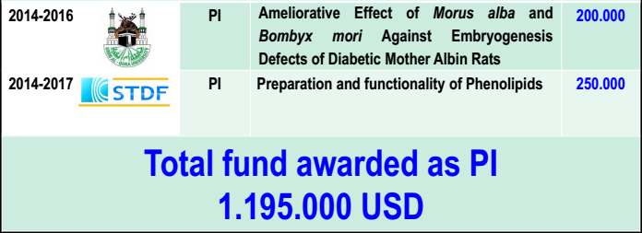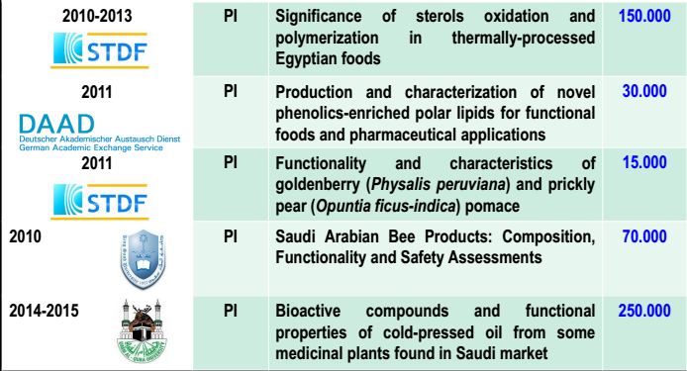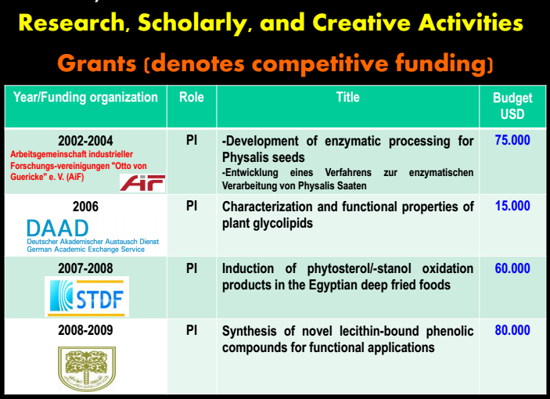

**Training Activities**

* Lecturing on **“How to write a research grant”**
* Lecturing on **“How to form and lead a research team”**
* Lecturing on **“Scientific research ethics”**
* Lecturing on **“How to use scientific databases”**
* Lecturing on **“How to evaluate research article”**
* Lecturing on **“International publishing” Since 2012 certified-DAAD trainer to** **present *International Publishing* module**

**References**

**1-Prof. Dr. Liangli Yu**

Professor and Acting Chair Director, Graduate Program in Nutrition, University of Maryland, College Park, Maryland 20742, USA.

Tel: 301.405.0761, Fax: 301.314.3313

Emal: lyu5@umd.edu

**2-Prof. Dr. Lothar W. Kroh**

Food Chemistry Institute, Berlin University of Technology, Gustav-Meyer-Allee 25, TIB 4/3-1, D-13355 Berlin, Germany. Fax: 0049 030 31472823.

Email: [lothar.kroh@tu-berlin.de](mailto:lothar.kroh@tu-berlin.de)

**3- PD Dr. Jӧrg-Thomas Mӧrsel**

Food Chemistry Institute, Berlin University of Technology, Gustav-Meyer-Allee 25, TIB 4/3-1, D-13355 Berlin, Germany. Tel: 0049 15782099723.

Email: thomas.moersel@ubf-research.com

# 4- Prof. Dr. Sascha Rohn

Institut für Lebensmittelchemie, Universitat Hamburg, Grindelallee 117, 20146 Hamburg, Germany.

Tel: 0049 040 42838-7979  
**E-Mail:** [rohn@chemie.uni-hamburg.de](mailto:rohn@chemie.uni-hamburg.de)

**5- Prof. Mario Estévez**

IPROCAR Research Institute, University of Extremadura, 10003 Cáceres, Spain.

E-mail: [mariovet@unex.es](mailto:mariovet@unex.es)

**6- Prof. Dr. Muhammad Iqbal Bhanger**

National Center of Excellence in Analytical Chemistry, University of Sindh, Jamshoro-76080-Pakistan.

Email: [dbhanger2000@yahoo.com](mailto:dbhanger2000@yahoo.com)

**7- Dr. Bertrand Matthäus**

Max Rubner-Institute, Federal Research Institute for Nutrition and Food, Department for Lipid Research, Schützenberg 12, D-32756 Detmold, Germany.

Tel.: +49 (0) 05231 741-303

Email: [bertrand.matthaus@mri.bund.de](mailto:bertrand.matthaus@mri.bund.de)

**Patents**

**1-Mohamed Fawzy Ramadan Hassanien**

**Formulation and functionality of Phenolipids for novel foods and pharmaceuticals**

|  |  |
| --- | --- |
| **Publication number** | **WO2016097779 A1** |
| **Publication type** | **Application** |
| **Application number** | **PCT/IB2014/002849** |
| **Publication date** | **Jun 23, 2016** |
| **Filing date** | **Dec 19, 2014** |
| **Priority date** | **Dec 19, 2014** |
| **Also published as** | [**US20160175377**](https://google.com/patents/US20160175377?cl=en) |

[**https://google.com/patents/WO2016097779A1?cl=en**](https://google.com/patents/WO2016097779A1?cl=en)

[**https://patentscope.wipo.int/search/en/detail.jsf?docId=WO2016097779**](https://patentscope.wipo.int/search/en/detail.jsf?docId=WO2016097779)

**2-Assiri A., Elbanna K., and Ramadan M.F.**

**Cold-pressed oregano (*Origanum vulgare*) oil as a long-lasting antidermatophytic drug**

**-Under filling**